Term Project

Developing a Scouting Infrastructure for a Football team

By Rushikesh Kulkarni
kulkarni.rush@northeastern.edu

Submission Date: 03/31/2024

EMGT5220: Engineering Project Management, Spring 2024
Northeastern University

Instructor: Prof. George Kontopidis

Table of Contents
1. Purpose 3
2. Objective 3
3. Scope 3
4. Funder 3
5. Critical Success Factors 3
6. Technical Approach 4
7. Assumptions 4
8. Organization 4
9. Project Plan 6
a. Work Breakdown Structure 6
b. Resource Allocation and Responsibility Chart (RACI) 7
c. Financial plan 8
d. PERT Chart 10
e. GANTT Chart 11
10. Risk Assessment 11
a. SWOT Analysis 11
b. RPN Priority number 12
c. 5x5 Risk matrix 13
d. Risk Assessment and Mitigation plan 13
11. Resource allocation 13
12. Conclusion 15
Appendix 15
1) Mind map 15
2) Activity Diagram 15
3) Class Diagram 16
4) Risk table 17
13. References 18

Purpose
Technological improvements may not be completely utilized by conventional scouting techniques, hence hindering the efficient discovery of potentially talented footballers. This leads to erroneous evaluations, overlooked prospects, and possible overspending in the transfer market. In order to secure a competitive edge in player recruitment, the project aims to update scouting techniques. The project's unique selling point is its effective use of data analytics, latest technology, and international scouting networks to find football talent. This approach aims to optimize the use of resources and maximize the team's success in acquiring top-tier talent.

Objective
The project aims to set up a Scouting department for PC Football Club that will establish a process of player recruitment by using data analytics, latest technology and a wide global network to identify and recruit top-tier football talent which will be done through platform that will be developed. This project is not categorized as business in traditional sense but rather considered as a process-oriented project aimed at enhancing the capabilities of the football team in talent scouting and recruitment. The main purpose is to guarantee a steady stream of players of the highest caliber, building a strong and dynamic squad that can accomplish short- and long-term performance goals.

Scope
The project includes the implementation of a comprehensive scouting infrastructure, incorporating advanced data analytics tools, AI-driven player assessments, and the establishment of a global scouting network. To establish a solid foundation, the scouting team will focus on recruiting and training scouts specialized in critical locations and technological aspects. Additionally, implementing a data analytics platform is essential for in-depth performance analysis and player research, which will delivered by the Data science team. Moving towards advanced player evaluation and recruitment involves a comprehensive approach, where the combined efforts of the scouting and data science team along with the medical department will be required. This includes employing psychological profiling, sports science, and cultural fit evaluations for a thorough examination of players. The recruitment process is further refined by utilizing data to make informed decisions and streamlining communication channels for more effective talent acquisition.

Funder
The financing for the project will come from the professional football team's owners, reflecting a deliberate investment in team building and talent acquisition. Additionally, private investors seeking long-term return on investment (ROI) through successful transfer markets and advancements in club and club valuations will also contribute funds. The rationale behind this investment is to secure a competitive edge in player recruiting and ensure long-term on-field performance. The funds will be used for training, expanding the scouting network, getting advanced technology, and ongoing maintenance. The project is expected to yield a return on investment in the form of successful player transfers, elevated fan involvement, and higher club worth. The sophisticated scouting system seeks to locate elite athletes which could result in lucrative moves. It is anticipated that enhanced team performance will increase the club's valuation and give investors rewards. Growing interest from fans will boost revenue, highlighting the project's calculated investment in long-term performance and financial gain.

Critical Success Factors
- Active involvement and support from key stakeholders, including the football team's management, coaching staff, and scouting department, are essential. This includes clear communication of project objectives, alignment of expectations, and timely decision-making to address any challenges that arise during implementation.
- The project's success depends on the effective integration and adaption of new technologies, such as artificial intelligence systems and data analytics tools. This entails tackling technological risks with thorough testing, training, and continuing support, such as compatibility problems, data security challenges, and system scalability.
- Leveraging external skills and resources requires effective collaboration with service providers, such as technology consultants, software developers, or data suppliers. This entails drafting precise contract terms, outlining roles and duties, and controlling the risks related to relying on outside partners.
- To reduce interruptions and guarantee project resilience, proactive risk identification, assessment, and mitigation. This entails creating backup plans, keeping an eye out for risk indicators, and acting quickly to fix any project plan deviations.

Technical Approach
- Utilizing state-of-the-art data analytics involves employing advanced statistical models and machine learning algorithms to analyze player data. This includes performance metrics, playing styles, and other relevant statistics to gauge a player's potential impact on the team.
- Implementing AI algorithms for initial player evaluations entails developing automated systems that can process large datasets quickly. This reduces manual labor and increases productivity, allowing scouts and analysts to focus on more nuanced aspects of player assessment.
- Creating a single, comprehensive database involves designing a centralized repository for all scouting data. This includes player profiles, performance metrics, and historical data. Custom software tools are developed to streamline data entry, retrieval, and collaboration among the scouting team.
- Establishing a global scouting network incorporates the use of technology to connect scouts worldwide. Real-time data sharing enables scouts to collaborate seamlessly, providing insights into potential recruits from different regions. Secure communication channels ensure confidentiality in data exchange.
- Developing custom software tools involves creating applications tailored to the team's specific scouting needs. These tools may include dashboards for real-time performance tracking, automated reporting systems, and interfaces for data visualization.

Assumptions
The project assumes that: -
- relevant data sources for player performance, scouting reports, and historical data will be accessible and reliable
- advancements in data analytics, artificial intelligence, and technology infrastructure will continue to support the development and implementation of scouting tools and systems
- compliance with relevant regulations and standards governing data privacy, player rights, and scouting practices.
- an understanding of market dynamics, including player transfer market trends, competitive landscape, and club strategies.
- stability in global events and geopolitical factors that may impact player availability, travel restrictions, and international scouting operations

Organization
This project will be developed under the direct supervision of the CEO of the football club. The CEO will get all the ongoings and updates about the project from the Director of Football. The Director of Football will be the heart of this project. He will assign the goals of the project for the Project Manager, along with the budget and timeline. All departments will report to the Director of Football. Team members from the Scouting department and Data Science department will report to the project manager, who is in charge of the overall project, as well as the functional managers, i.e., the department heads who are in charge of their own departments under the matrix organizational structure for this project.
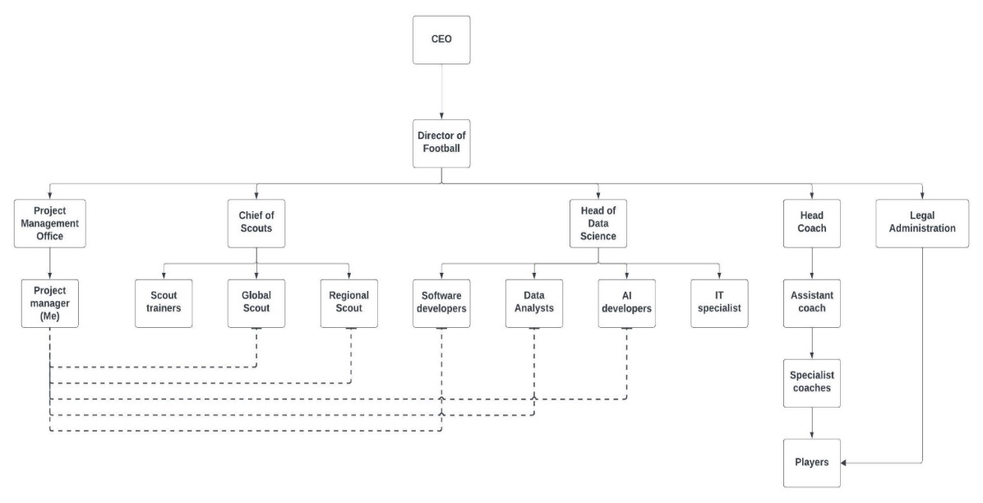
Fig. 1: - Organization Chart

Project Plan

Work Breakdown Structure
The following table is the Work Breakdown of the tasks that are to be completed with the person responsible to complete that task and the steps that will be followed along with the duration and number of people that are required to complete that task.
Table 1: Work Breakdown Structure
Task ID | Task Description | Responsible | Duration (Weeks) | Dependencies | Steps | Team size
1.0 | Planning and Analysis | Director of Football | 4 | - | Defined Scouting need, technology options, and evaluation processes | 3
2.0 | Data Acquisition & Management | Head of Data Science
2.1 | Identify Data Sources | Data Analyst | 4 | 1.0 | Defined sources for player performance, scouting reports, historical data | 3
2.2 | Develop Data Acquisition Tools | Data Analyst, IT Department | 4 | 2.1 | APIs, web scraping tools, or manual data entry methods | 2
2.3 | Data Cleaning & Integration | Data Analyst, IT Department | 4 | 2.2 | Standardize data format, remove errors, integrate into central database | 2
3.0 | Player Evaluation & Modelling | Head of Data Science
3.1 | Feature Engineering & Selection | Data Analyst | 4 | 2.3 | Identify relevant player performance & scouting data features | 2
3.2 | Model Development & Training | Data Analyst | 8 | 2.2, 3.1 | Develop & train statistical & machine learning models for player evaluation | 3
3.3 | Model Validation & Testing | Data Analyst | 4 | 3.2 | Evaluate model performance, accuracy, and potential biases | 3
4.0 | Technology & Infrastructure | IT Specialist
4.1 | Software Selection & Procurement | IT Department, Software Developers | 4 | 1.0 | Choose scouting database, communication platform, and data visualization tools | 2
4.2 | System Implementation & Customization | IT Department, Software Developers | 4 | 4.1 | Configure software, integrate with models, train & support users | 2
5.0 | Operationalization & Integration | Chief of Scout
5.1 | Define Scouting Workflow & Roles | Chief of Scouts, Head Coach | 2 | 3.3, 4.2 | Establish scouting assignments, communication protocols, reporting procedures | 2
5.2 | Integrate Models & Data into Decisions | Chief of Scouts, Data Analyst | 2 | 3.3, 4.2 | Utilize models for player evaluation, generate reports, visualize insights | 2
5.3 | Training & User Adoption | Training Department | 4 | 5.2 | Train scouts & staff on technology & processes, ensure user buy-in | 2
6.0 | Terminate Project | Project Manager | 4 |  | Complete handover to Director of Football | 1

Resource Allocation and Responsibility Chart (RACI)
The following chart defines the tasks and person responsible to complete it along with those accountable for the completion of the task and those who need to be consulted and informed about the task within the organization.
Table 2: RACI chart
Task ID | Task Description | Responsible (R) | Accountable (A) | To be Consulted (C) | To be Informed (I)
1.0 | Project Setup & Planning | Director of Football | CEO | All Staff | All Staff
2.0 | Data Acquisition & Management | Data Analyst | Chief of Scouts, Director of Football | IT Department | All Staff
2.1 | Identify Data Sources | Data Analyst | Chief of Scouts | IT Department, Legal Department (for data privacy) | All Staff
2.2 | Develop Data Acquisition Tools | Data Analyst | Chief of Scouts, Director of football | Software developers | All Staff
2.3 | Data Cleaning & Integration | Data Analyst | Chief of Scouts, Director of Football | AI developers | All Staff
3.0 | Player Evaluation & Modeling | Data Analyst | Chief of Scouts, Director of Football | AI developers | All Staff
3.1 | Feature Engineering & Selection | Software Developers | Chief of Scouts, Director of Football | AI developers | All Staff
3.2 | Model Development & Training | Data Analyst | Chief of Scouts, Director of Football | AI developers | All Staff
3.3 | Model Validation & Testing | Data Analyst | Chief of Scouts, Director of Football | AI developers | All Staff
4.0 | Technology & Infrastructure | IT Specialist | Head of Data Science | Project Manager, Software developers | All Staff
4.1 | Software Selection & Procurement | IT Specialist | Head of Data Science | Project Manager, Software developers | All Staff
4.2 | System Implementation & Customization | Software Developer | Head of Data Science | Project Manager, Data Analyst | All Staff
5.0 | Operationalization & Integration | Chief of Scouts | Director of Football | Data Analyst, IT Department | All Staff
5.1 | Define Scouting Workflow & Roles | Director of Football | Director of Football | Assistant Coaches, Scouts | All Staff
5.2 | Integrate Models & Data into Decisions | Chief of Scouts | Head Coach, Director of Football | Assistant Coaches, Scouts | All Staff
5.3 | Training & User Adoption | Software developer | Director of Football | Project Manager, IT Department | All Staff
6.0 | Terminate project | Project Manager | CEO | Chief of Scouts, Head Coach, Data Analyst | All Staff

Financial plan
The following charts give a rough estimate of the budget that will be required for this project.
Table 3: Estimated Project Budget
Category | Description | Estimated Cost (USD)
Personnel
Data Analyst | Salary + Benefits (1 year) | $110,000
IT Specialist | Salary + Benefits (1 year) | $100,000
Project Manager | Salary + Benefits (6 months) | $62,500
Software Developers | Hourly rate x Number of hours | $150,000
Technology & Infrastructure
Scouting Database Software | Annual License fees | $30,000
Data Acquisition Tools (APIs, web scraping tools) | Development/Subscription costs | $10,000
Data Visualization Tools | Annual License fees | $10,000
Communication Tools (secure platform) | Annual License fees | $ 15,000
Hardware (servers, workstations) | One-time purchase | $5,000
Data Acquisition
Historical data purchase | One-time fee | $10,000
API access fees | Annual fees | $10,000
Training & User Adoption
External training programs | Cost per participant | $14,000
Internal training materials & workshops | Development costs | $7,000
Contingency | Unforeseen expenses | 10% of total budget

The table given below gives a more detailed account of the monthly expenditure that is required for the project.
Table 4: Project Budget
Monthly Budget
Task ID | Estimate | 1 | 2 | 3 | 4 | 5 | 6 | 7 | 8 | 9 | 10 | 11
1 | 10000 | 10000
2 | 180000
2.1 | 20000 |  | 20000
2.2 | 20000 |  |  | 20000
2.3 | 20000 |  |  |  | 20000
3 | 320000
3.1 | 80000 |  |  |  |  | 80000
3.2 | 160000 |  |  |  |  |  | 80000 | 80000
3.3 | 80000 |  |  |  |  |  |  |  | 80000
4 | 96000
4.1 | 24000 |  | 24000
4.2 | 24000 |  |  | 24000
5 | 216000
5.1 | 36000 |  |  |  |  |  |  |  |  | 36000
5.2 | 36000 |  |  |  |  |  |  |  |  | 36000
5.3 | 16000 |  |  |  |  |  |  |  |  |  | 16000
6 | 32000 |  |  |  |  |  |  |  |  |  |  | 32000
Total | 854000 | 10000 | 44000 | 44000 | 20000 | 80000 | 80000 | 80000 | 80000 | 72000 | 16000 | 32000

PERT Chart
The PERT chart provides a visual representation of the timeline of the project schedule and how the tasks are broken down into multiple individual tasks.
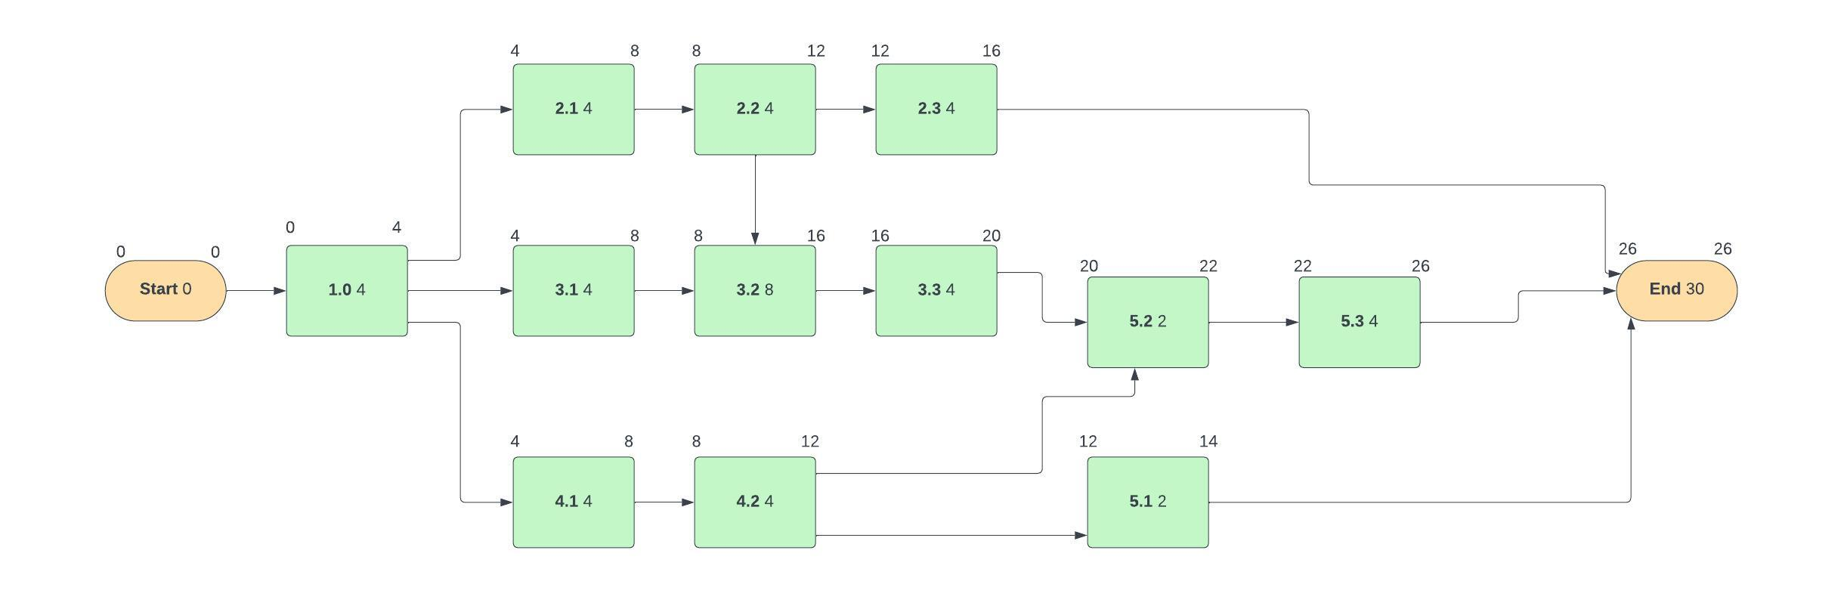
Fig. 2: - PERT chart
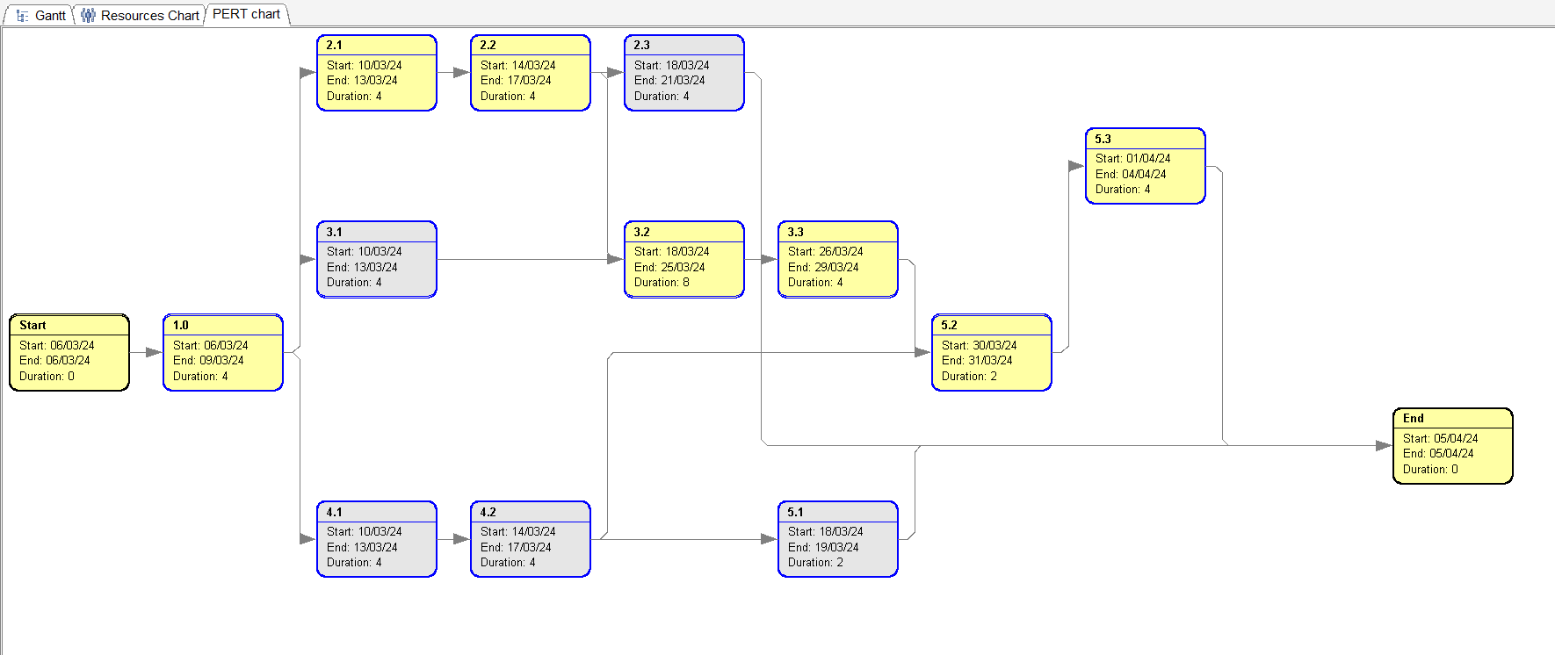
Fig 3: - Auto-Generated PERT chart from GanttProject

GANTT Chart
The Gantt chart illustrates the project schedule. The chart below was produced from GanttProject application where the tasks were identified from the WBS and listed here. This chart makes it easier to track the project schedule.
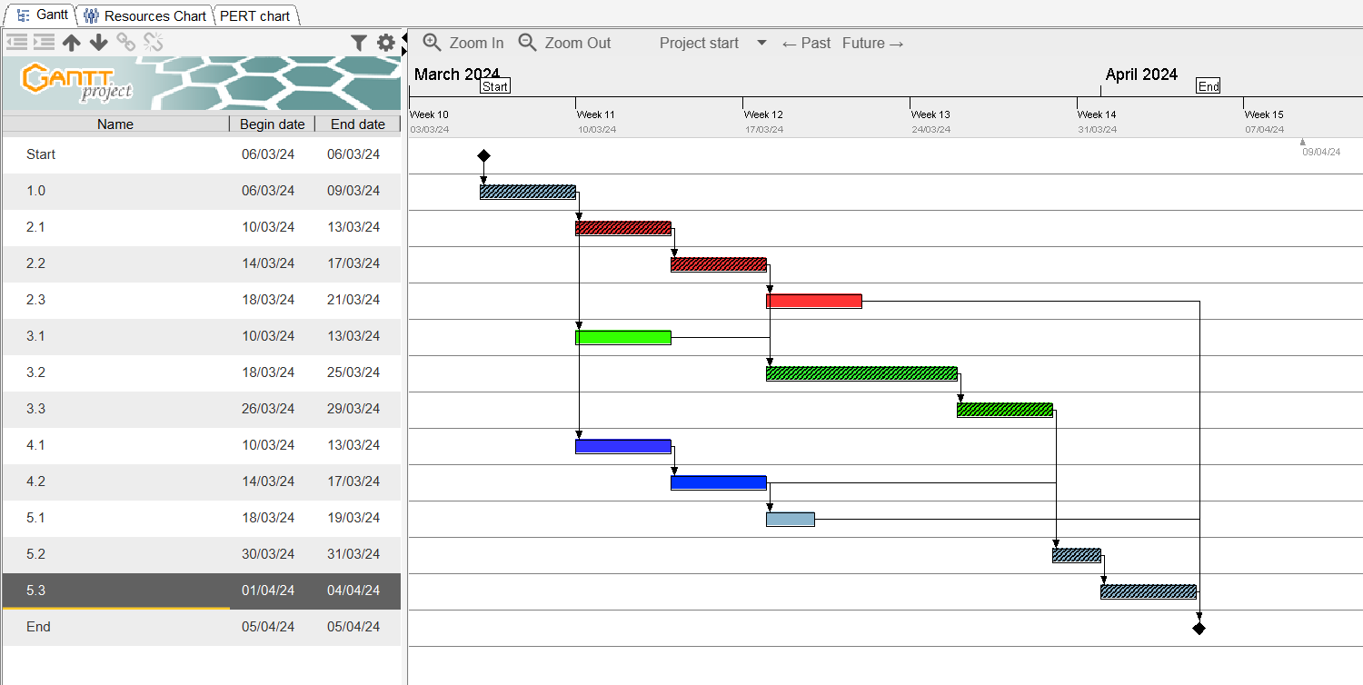
Fig. 4: - GANTT chart

Risk Assessment

SWOT Analysis
The SWOT analysis provides a comprehensive understanding of the project's internal strengths and weaknesses, as well as the external opportunities and threats it faces. This information has been used to develop strategies to capitalize on strengths, mitigate weaknesses, leverage opportunities, and address threats, ultimately improving the project's chances of success.
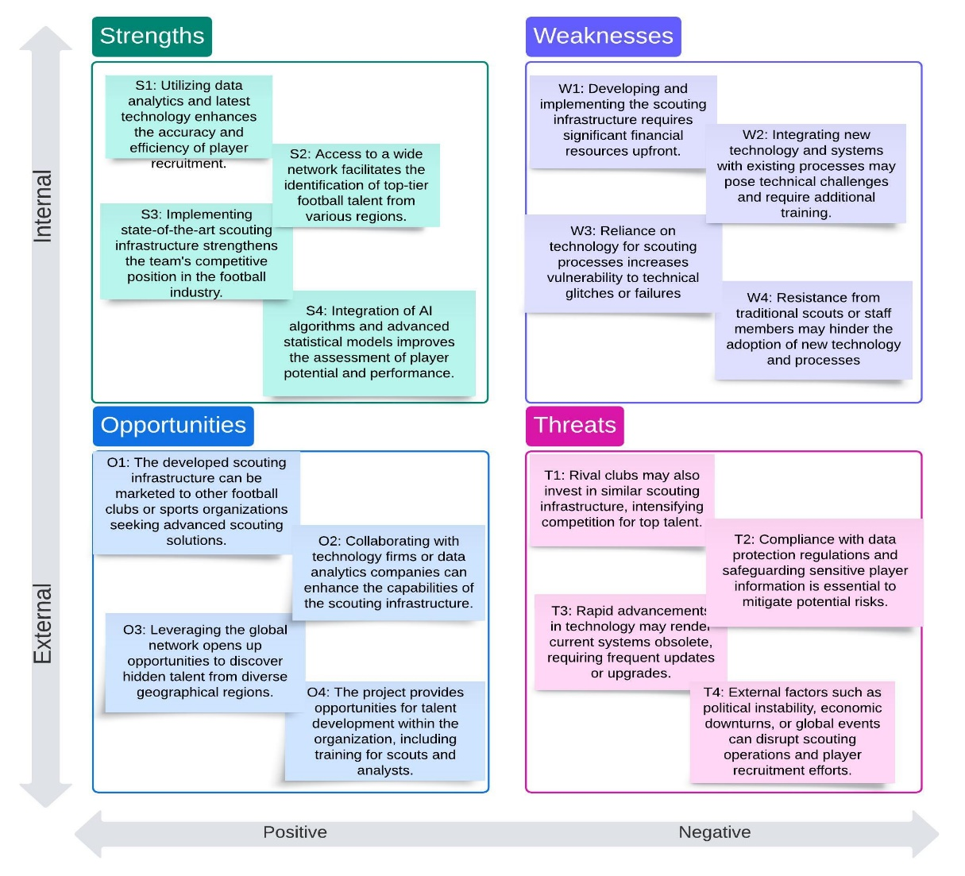
Fig. 6: - SWOT Analysis chart

RPN Priority number
The RPN (Risk Priority Number) table is a tool used in risk management to prioritize risks based on their severity, probability, and impact. It helps project teams identify and focus on the most critical risks that could potentially have the greatest negative impact on the project's objectives. The RPN table typically assigns a numerical value to each risk based on its probability of occurrence, the severity of its impact, and its detectability. By calculating the RPN for each risk, teams can rank them in order of priority and allocate resources more effectively to manage and mitigate the most significant risks first.
Table 5: FMEA table
Risk | Probability (P) | Impact (I) | Severity (S) | RPN (P x I x S)
W1: Financial Risk | 3 | 4 | 3 | 36
W2: Data Privacy | 3 | 4 | 3 | 36
W3: Technological Obsolescence | 4 | 3 | 4 | 48
W4: Traditionalists | 2 | 3 | 2 | 12
T1: Competitive Pressure | 3 | 4 | 4 | 48
T2: Technology Integration Risk | 4 | 3 | 4 | 48
T3: Talent Adoption Risk | 3 | 3 | 3 | 27
T4: Geopolitics | 3 | 2 | 3 | 18

5x5 Risk matrix
The 5x5 risk matrix provides a visual representation of risks, helping project teams prioritize their efforts and allocate resources effectively to manage and mitigate the most critical risks.
Probability
 | W1 |  |  | W3
 | W2 |  | T2 | T1
T3 | T4
W4
Impact

Low risk- W; Moderate risk- W; High risk- W

Risk Assessment and Mitigation plan
- Financial Risk: Careful financial planning, including emergency funds for unforeseen expenses, is necessary for risk mitigation.
- Technology Integration Risk: To reduce integration difficulties, involve IT specialists early in the project, carry out thorough testing, and use staggered deployment.
- Talent Adoption Risk: Educate employees thoroughly, highlight the advantages of the new technology, and effectively communicate with them about any concerns.
- Competitive Pressure Risk: Enhance the team's unique selling propositions, such as specialized scouting methodologies or exclusive talent networks, to mitigate competitive pressures.
- Data Privacy Risk: To secure player information, make sure that data protection laws are followed, put strong data security measures in place, and carry out frequent audits.
- Risk of Technological Obsolescence: Keep abreast of new developments in the field, schedule frequent system updates, and make investments in scalable systems that can keep up with rapid technological change.

Resource allocation
Based on the RACI table and Gantt chart, we create a resource chart that depicts the resources that have been allocated for a give task to be completed. This chart has been produced by allocating resources for the tasks in the Gantt chart.
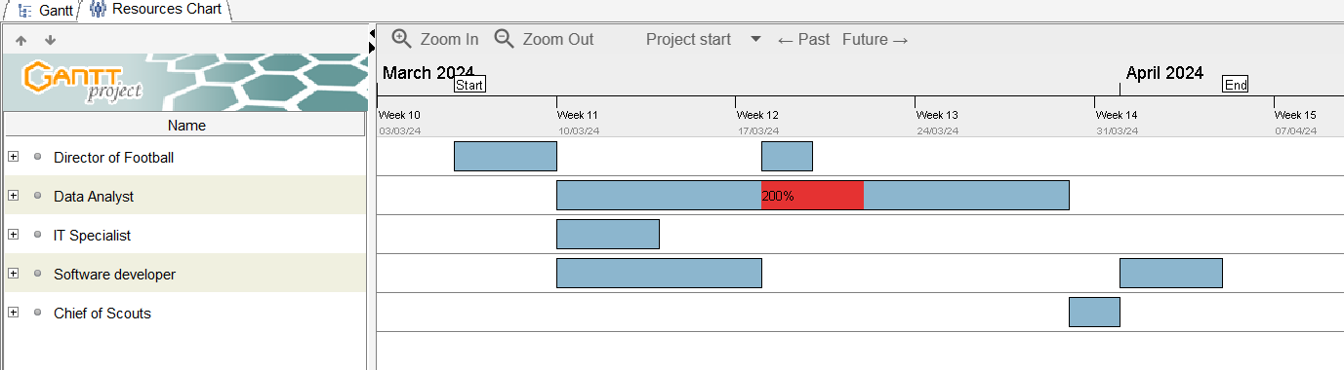
Fig. 5: - Resource allocation chart
As it can be seen, Data analysts are being overloaded with tasks and hence need to multitask. In order to avoid them having to multitask, changes were made in the Gantt chart. The data analysts are being made to multitask tasks 2.3 and 3.2 together. For this, we assume that task 3.2 can be handled by Software developers and thus make them responsible for completing that task.
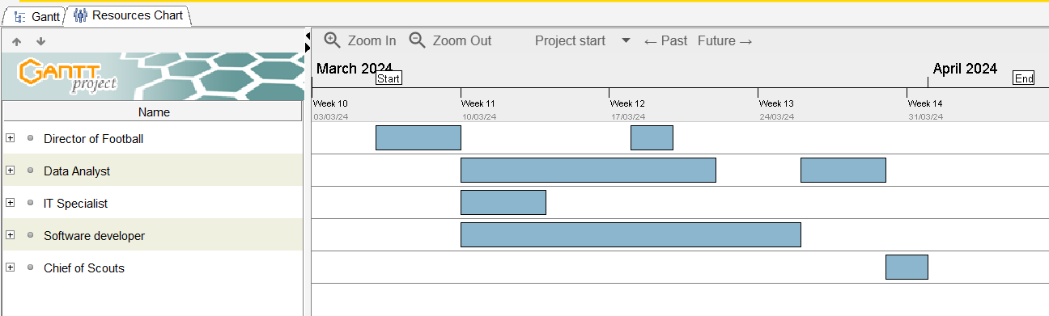
Fig. 6: - Updated Resource allocation chart
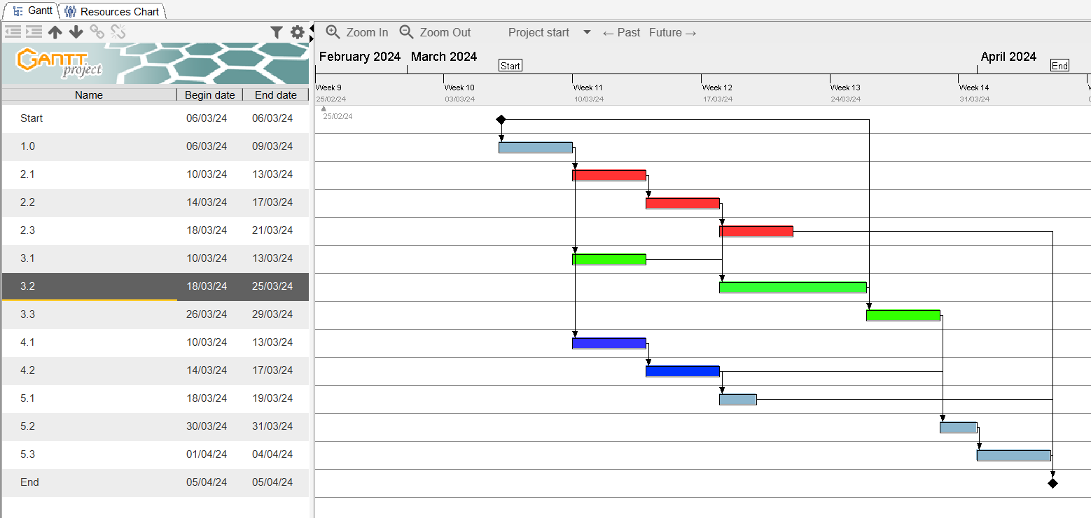
Fig. 7: - Updated Gantt chart

Conclusion
We determined that in order to transform the scouting process, cutting-edge data analytics and cutting-edge technologies are essential through careful planning and study. Using a global scouting network, AI-powered player evaluations, and robust data management systems have all greatly improved the football team's ability to find and hire elite players. Our technical approach focused on leveraging bespoke software tools, AI algorithms, and data analytics to improve scouting workflows, expedite player evaluation, and elevate decision-making. As a result, the project has put the football team in a position to meet both short- and long-term performance goals and strengthen its competitive position in the sector. This endeavour’s success serves as a reminder of how important creativity and calculated risk-taking are to long-term professional football success.

Appendix

Mind map
The mind map has visually represented key components, dependencies, stakeholders, technological aspects, and objectives. It organizes information into a hierarchical structure, illustrating how tasks and phases relate to each other and the overall project goal. By providing a comprehensive overview in a concise and visually engaging format, the mind map facilitates better understanding and communication among project team members and stakeholders.
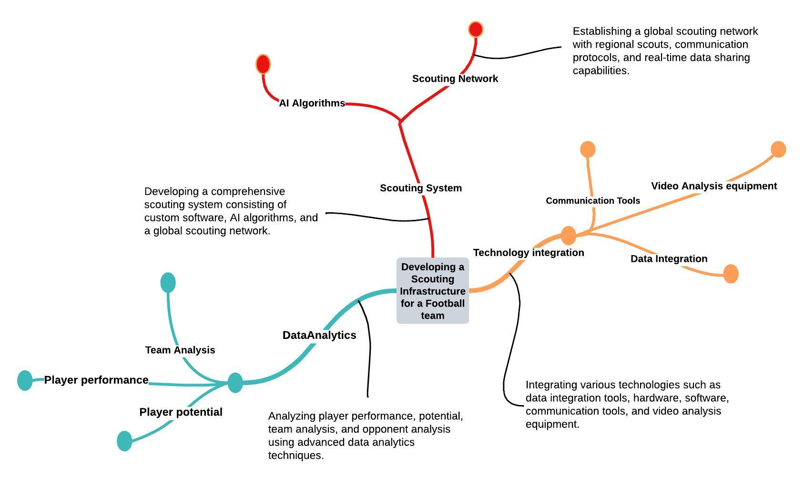
Fig. 7: Mind map

Activity Diagram
The activity diagram depicts the various tasks and steps involved in setting up the scouting department and implementing the infrastructure. It visually represents the order of operations, decision points, parallel activities, and loops, providing a clear understanding of the project workflow and helping to identify potential bottlenecks or inefficiencies. This diagram serves as a valuable tool for project planning, analysis, and communication, enabling stakeholders to visualize the project's execution path and ensure smooth progress towards its objectives.
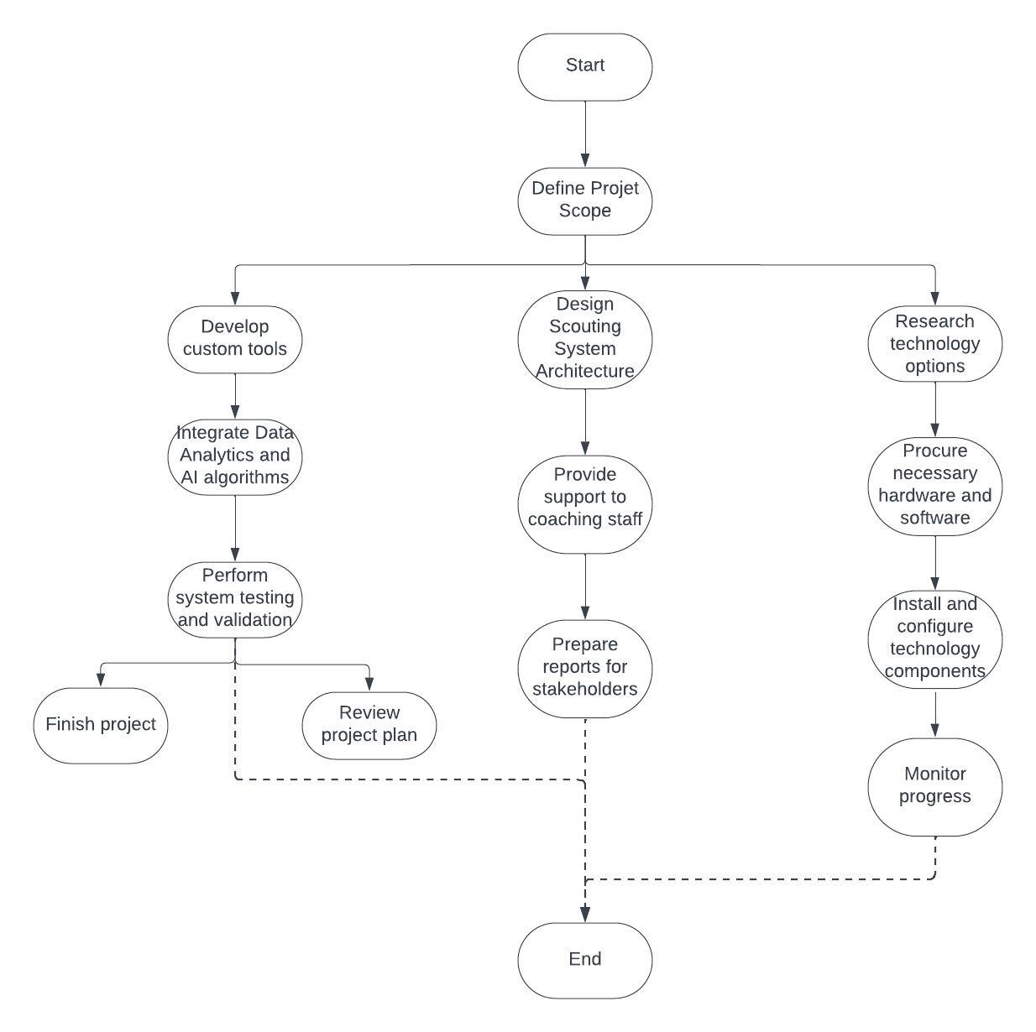
Fig. 8: Activity Diagram

Class Diagram
The class diagram represents the various entities or objects involved in the scouting infrastructure, such as players, scouts, data analytics tools, and databases. It visually depicts how these entities are organized and interact with each other within the system, highlighting inheritance, associations, and dependencies. By providing a high-level overview of the system's architecture and components, the class diagram aids in understanding the system's design and facilitates communication among stakeholders, developers, and designers involved in the project.
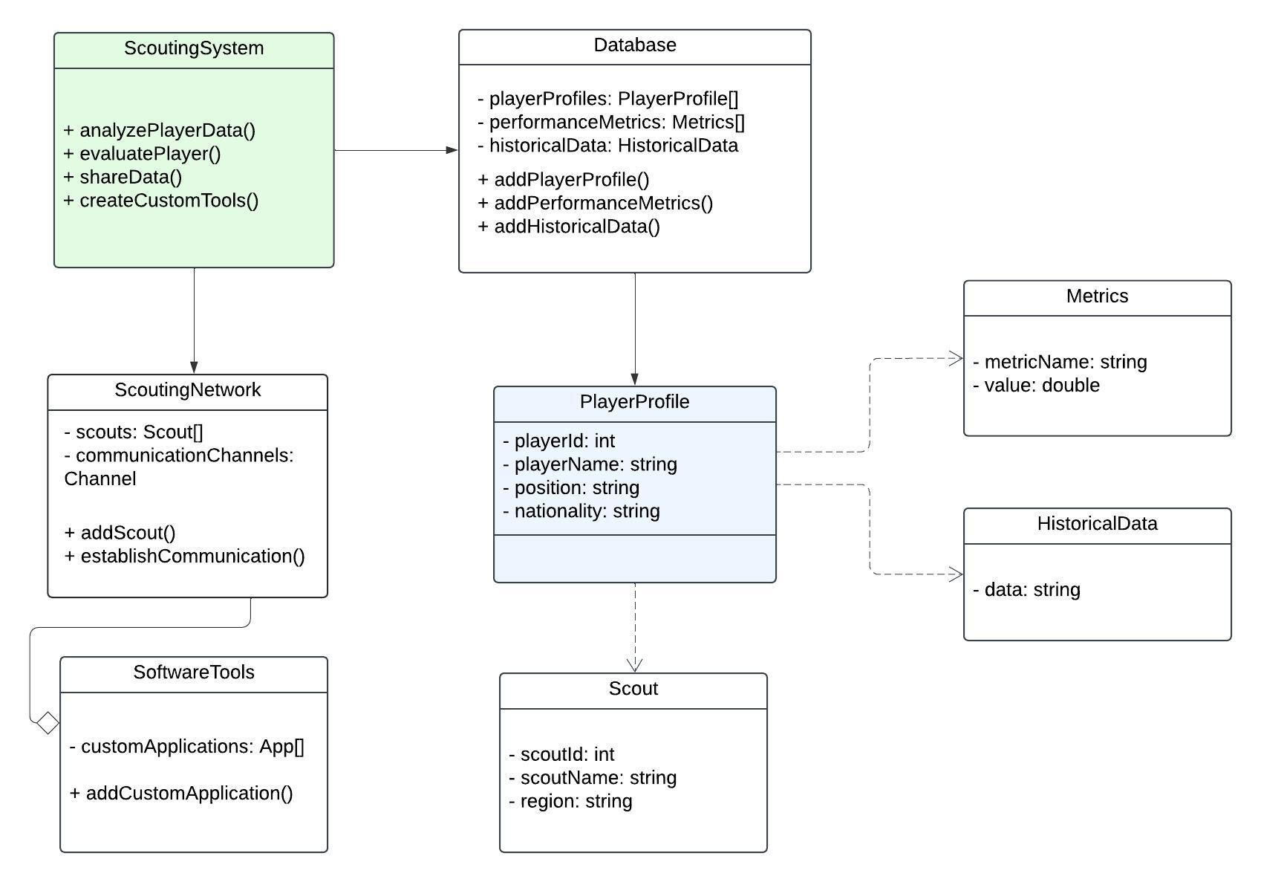
Fig. 9: Class Diagram

Risk table
A risk table provides a structured overview of potential risks associated with the project. This enables proactive risk management strategies to be implemented, minimizing the negative impact on project progress and outcomes. Additionally, the risk table serves as a communication tool, facilitating discussions among team members and decision-makers regarding risk mitigation measures and contingency plans.
Table 6: Risk table
Task ID | Task Description | D | F | R
1.0 | Planning and Analysis | 2 | 1 | 2
2 | Data Acquisition & Management | 3 | 2 | 6
2.1 | Identify Data Sources | 2 | 2 | 4
2.2 | Develop Data Acquisition Tools | 2 | 2 | 4
2.3 | Data Cleaning & Integration | 2 | 2 | 4
3.0 | Player Evaluation & Modelling | 3 | 2 | 6
3.1 | Feature Engineering & Selection | 2 | 2 | 4
3.2 | Model Development & Training | 3 | 2 | 6
3.3 | Model Validation & Testing | 2 | 2 | 4
4.0 | Technology & Infrastructure | 3 | 2 | 6
4.1 | Software Selection & Procurement | 2 | 2 | 4
4.2 | System Implementation & Customization | 2 | 2 | 4
5.0 | Operationalization & Integration | 3 | 2 | 6
5.1 | Define Scouting Workflow & Roles | 2 | 2 | 4
5.2 | Integrate Models & Data into Decisions | 2 | 2 | 4
5.3 | Training & User Adoption | 2 | 2 | 4
6.0 | Terminate Project | 1 | 1 | 1

References
- https://www.glassdoor.com/Salaries/index.htm
- Jack R. Meredith and Samuel J. Mantel. 2002. Project Management: A Managerial Approach. John Wiley & Sons, Inc., USA.

